I wasn’t able to get SQL connected in IBM. I just ended up using the DB2 platform to run the queries.

1.Unique Launch Sites



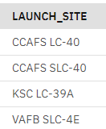

2. Display 5 records where launch sites begin with the string ‘CCA’

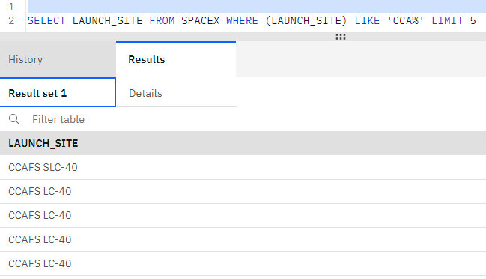

3.Display the total Payload mass carried by boosters launched by NASA(CRS)

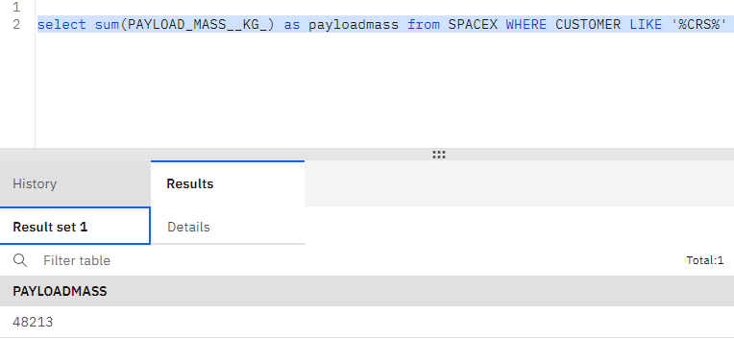

4.Display average payload mass carried by booster version F9v1.1

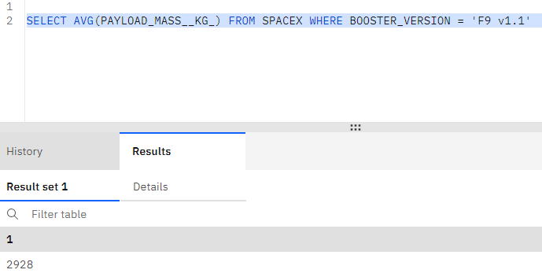

5.List the date when the first successful landing outcome in ground pad was achieved

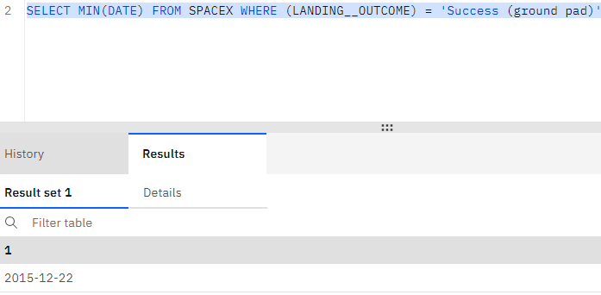

6.List the names of the boosters which have success in drone ship and have payload mass greater than 4K but less than 6K

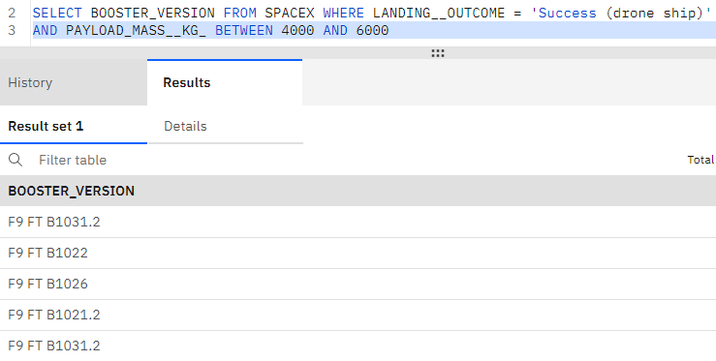

7.List the total number of successful and failure mission outcomes

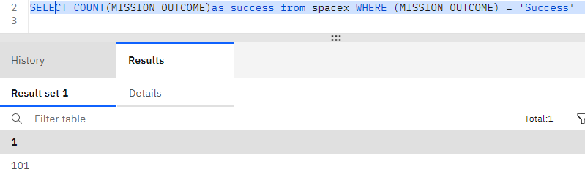

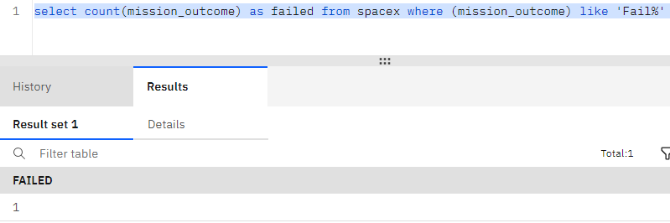

8.List the names of the booster_versions which have carried the maximum payload mass. Use subquery

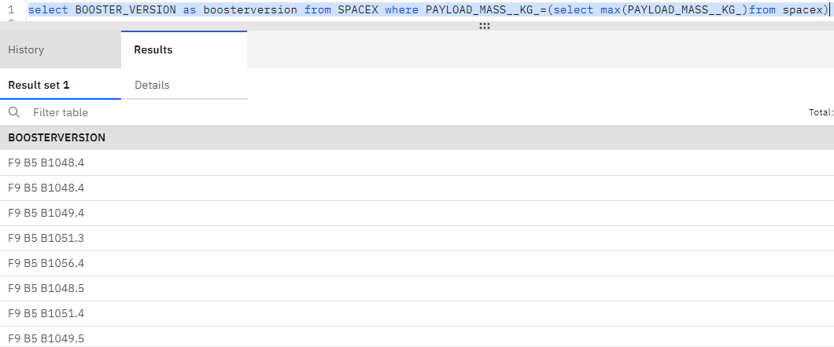

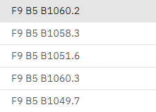

9.List the records which will display the month names, failure landing_outcomes in drone ship, booster versions, launch_site for the months in year 2015

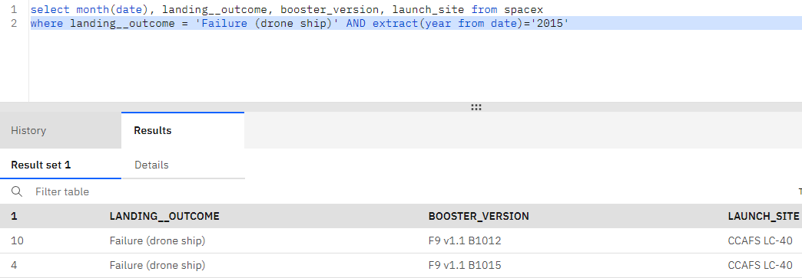

10. Rank the count of landing_outcomes between the date 2010-06-04 and 2017-03-20 in descending order



